MGMT 5490 – Irrational and Rational Thinking and Judgment in Management
Class 6: In class exercise
Name: ___________________________ Student ID: _________________

Task 1: Complete each of the four cells with one of the following options
- ambiguous verification
- conclusive verification
- ambiguous falsification
- conclusive falsification

Note: U = all possible instances; T = the TRUTH; H = the hypothesis in mind

Example:
Case 1: When T includes H
e.g., T = any ascending digits; H = ascending digits with equal distance
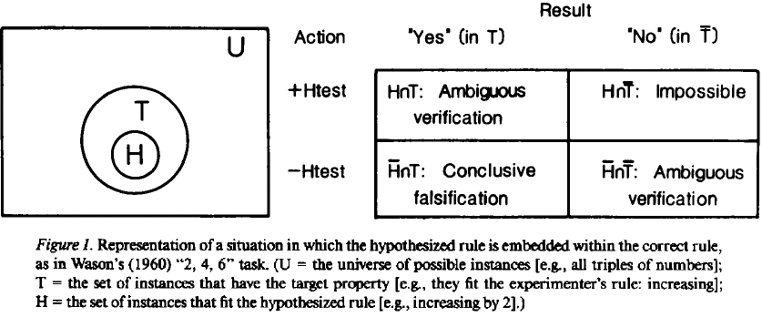

Case 2: When T and H overlap
e.g., T = any ascending digits from 2-10; H = any ascending digits from 1-6
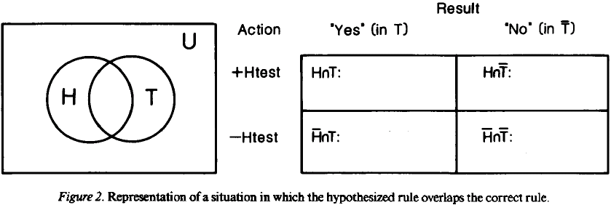

 | “yes” (in T) | “No” (in T)
+H test | Ambiguous Verification  e.g. 2-3-4 | Conclusive falsification  e.g. 1-2-3
-H test | Conclusive falsification  e.g. 4-5-6 | Ambiguous Verification  e.g. -1-0-1

Case 3: When H includes T
e.g., H = any digits; T = any ascending digits
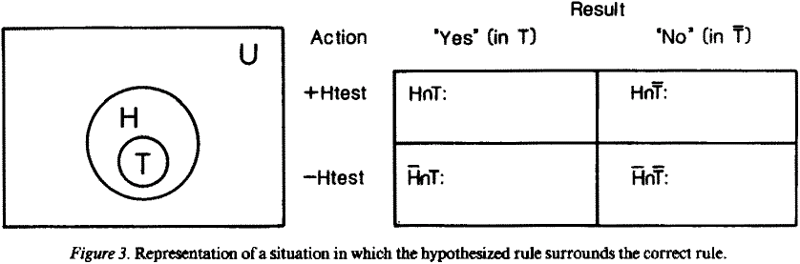

 | “yes” (in T) | “No” (in T)
+H test | Ambiguous Verification  e.g. 2-3-4 | Conclusive falsification  e.g. 3-2-1
-H test | Impossible | Ambiguous Verification  e.g. A-B-C

Case 4: When H and T do not overlap
e.g., T = any ascending digits; H = any descending digits
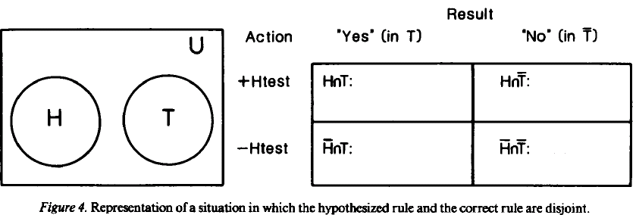

 | “yes” (in T) | “No” (in T)
+H test | Impossible | Conclusive Falsification  e.g. 1-2-3
-H test | Conclusive Falsification  e.g. 3-2-1 | Ambiguous Verification  e.g.1-3-2

Case 5: When H = T
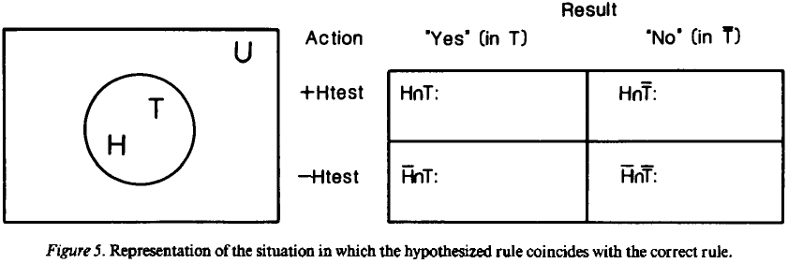
 | “yes” (in T) | “No” (in T)
+H test | Ambiguous Verification  e.g. 2-3-4 | Impossible
-H test | Impossible | Ambiguous Verification  e.g. 4-3-2

Can you get my rule?
2 – 4 – 6
    - It conforms to a general rule in my mind
    - Your task is to discover this rule by the following :
1. Please hypothesize the “rule” I am using
2. Then, you have to generate a series of three numbers (triplet) to test the hypothesis; For each trial, I’ll tell you whether or not it fits the rule
3. Right down the hypothesis …
4. Right down Three triplets (A-B-C; Y-Z-X; D-E-F) you are going to ask me in order to find out the rule in my mind

******************************************************************************************************************
Trial 1:
The rule I am hypothesizing is: T(n) = 2n

The Triplet that I want to test | Ellick’s response
- 8-10-12 | Yes
- 8-12-20 | Yes
- 2-3-7 | Yes
What conclusion you made after Trial 1: Cannot
******************************************************************************************************************
Trial 2:
The rule I am hypothesizing is _________________________________

The Triplet that I want to test | Ellick’s response
What conclusion you made after Trial 2: __________________________________

******************************************************************************************************************
Trial 3:
The rule I am hypothesizing is _________________________________

The Triplet that I want to test | Ellick’s response
What conclusion you made after Trial 3: __________________________________
******************************************************************************************************************

